“Art Fair 2019”
Tuesday March 5th @ 5:30-7 in the Carisbrooke Gym
Student Project Form
– Please complete and return to Camille@carisbrookepac.ca -
Return by Sunday March 3rd, 2019
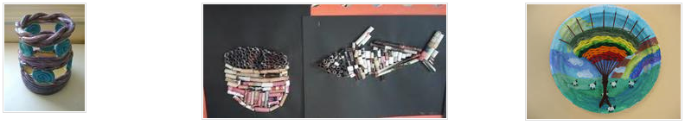
Student Name: ___________________________________ Grade: _______ Div. #: ________
Project Title and dimension:
_______________________________________________________________
Medium and Description/Inspiration:
__________________________________________________________________________________
PARENTS:
I _______________________ support my child’s application to make and present this project at the Art Fair on March 5th, 2019. Drop off projects from 8:20 to 8:45 AM and pick up after the event ends at 7:00 PM.
Parent Signature: _______________________________ Date: ____________________
Yes, I can volunteer to: set up gym (March 4th, 3:00 p.m.) ____________
drop off (March 5th, 8:20 to 8:45 AM) ____________
setting up projects (March 5th 8:45 to 10:00 AM) ____________
or Clean up (March 5th 7:00 to 8:00 PM) ____________

Please contact me at __________________________________(phone or e-mail).
Do you have questions? Contact Camille@carisbrookePAC.ca

